George and the dragon

What’s the word?
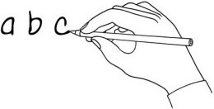
Write the word under the pictures.

knight | horse | village | cave | dragon | lake
food | animals | gold | king | army | princess

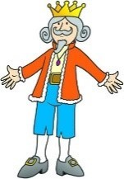 | 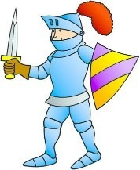 | 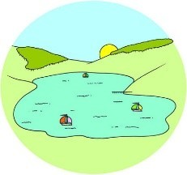 | 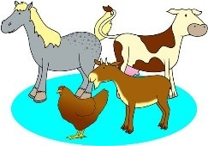 | 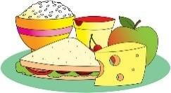 | 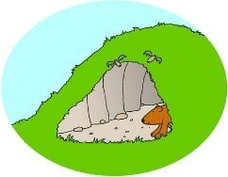
King | knight | lake | animals | food | cave
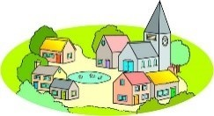 | 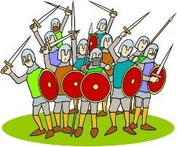 | 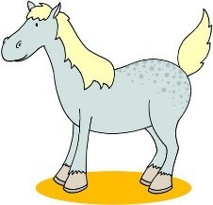 |  | 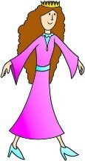 | 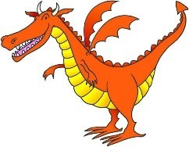
Village | army | Horse | Gold | princess | dragon

What’s the order?
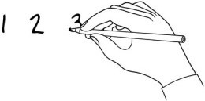
Listen to the story and put the sentences in order.

The villagers gave the dragon all their food, animals and gold and jewels. Everybody in the village was very happy.
3
7
1
4
2
6
5

George was a knight who had lots of adventures. The army tried to capture the dragon.
He heard about a dragon which attacked a village every day. George heard about the princess and killed the dragon.
The king gave the dragon his daughter, the princess.

www.britishcouncil.org/learnenglishkids
© British Council, 2017 The United Kingdom’s international organisation for educational opportunities and cultural relations. We are registered in England as a charity.

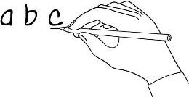
Make it right!
Find the mistake, underline it and write the correct word.
- George was a bad knight. brave
- A hermit told him about the giant. Awful things

- The villagers gave the dragon all their food, animals and children. jewels

- The knights of the king’s army were very brave. scared

- The king went to the lake to wait for the dragon. princess

- The dragon wanted to help the princess. eat

- George killed the princess. helped

- The dragon is a patron saint of many countries. Story of George’s bravery

Write and draw!
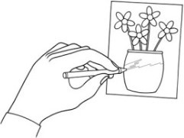
Are there any stories about knights or dragons from your country? Does your country have a patron saint? Write about it and draw a picture!

......Armenians had enemies and over the years they fought against them.............................................................................................................................

..................................................................................................................................

..................................................................................................................................

..................................................................................................................................

..................................................................................................................................
www.britishcouncil.org/learnenglishkids
© British Council, 2017 The United Kingdom’s international organisation for educational opportunities and cultural relations. We are registered in England as a charity.

